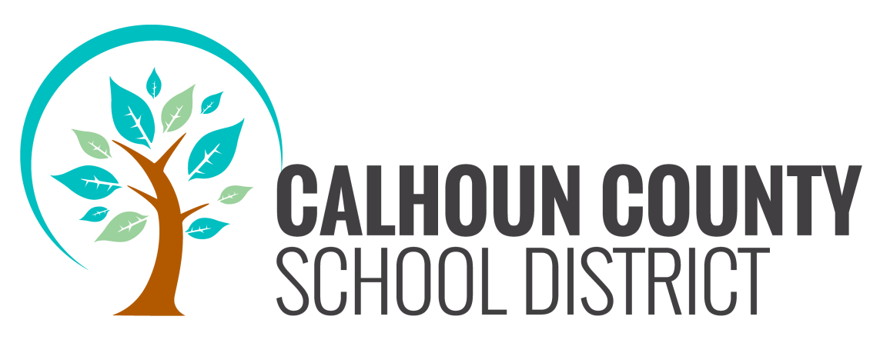
BOARD WORKSHOP
JULY 21, 2016
4:00 P.M.

AGENDA

1. CALL TO ORDER

2. ROLL CALL

3. PRAYER/PLEDGE OF ALLEGIANCE

4. TENTATIVE BUDGET

Additions in Blue Deletions in Red

